10.30: From Eq. (10.26), the power output is

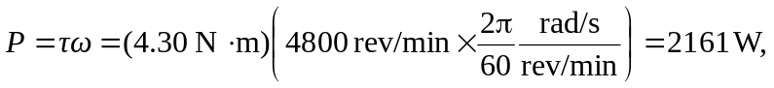
which is 2.9 hp.

